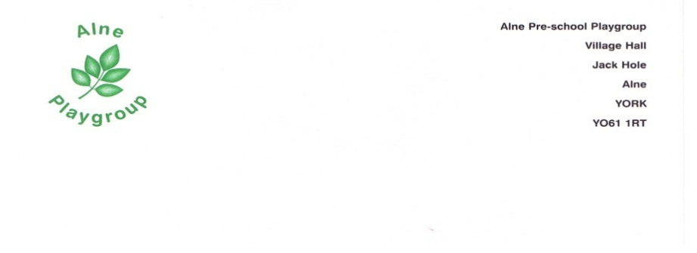
Alne Pre-school Playgroup Lost child policy/procedure

EYFS Links A Unique Child 1.3 Keeping Safe.

Enabling Environments 3.3 the Learning Environment, 3.4 The Wider Context

Statement of Intent

In the best-regulated situations, accidents can happen, we therefore have the following system for the protection of our children in place.

Aim
- Once all the children have arrived, the front door is locked.

- The manager or deputy manager if the manager is not in, personally checks in each child into the register, (as the child uses a self-registration picture on our emotions board).

- All staff members are vigilant in ensuring that children do not have access to the kitchen, office, or unaccompanied into the outside play area.

- A risk assessment is carried out in the summer term, to re-assess potential hazards.

- Throughout the morning the manager will conduct random head counts, ensuring that she knows where all the children are.

- Key people are encouraged to ensure that they are aware of where their own key children are, and in addition to be vigilant to where all the children are in the group.

- After outside play, the member of staff checks the whole of the outside area, locks the door and does a headcount, then comes to the manager to check on numbers, to ensure no child is left outside.

In the event of a child leaving the group unaccompanied, despite our safety controls, we will follow our procedure.

- Find out quickly – key people will be aware of whom of their group is in attendance and will be able to quickly identify if someone is missing.
- Search systematically – check every room in the building/outside areas/toilets etc. Gather the rest of the children for a story, with 2 adults, whilst the other 2 members of staff search again.
- Carers – call the child’s carer, in case they are trying to get home to them, alarming them as little as possible. If the carer is at work, call the emergency number. One adult should walk the immediate outside area, or to the child’s home, if it is within walking distance. We will support the carers as much as possible.
- The Police – If the above steps do not locate the child, we will contact the Police.
- Other contacts – we will also contact social care, the chair of the group, OFSTED, and the insurance manager at the Preschool Learning Alliance, national centre 0171 833 0991.
- Records – we will begin to build up a written record as soon as possible, including the last definite sighting of the child and anything unusual about their behaviour that day.
- Carers – we will be supportive to carers, being aware that they may be frightened, distressed or/and angry. We will ensure they understand that we are sorry that the incident has happened, that a full investigation is in hand, and that Social care have been informed and will also wish to investigate.
- Dealing with the media – all staff and volunteers will be advised what to say or to refer all enquiries and questions to the chair of the group. In contacting the Pre-school Learning Alliance national centre, they will contact our regional office, who will offer help and support.
- Informing other carers – Other carers will be given brief accurate information, as soon as possible. This may be as they collect their child, or a note home.
- Staff reassurance – Once the child is found and safely returned, the manager will offer support to the rest of the staff, who may have a wealth of emotions. A staff meeting will be arranged within the next week, to discuss the implications and the matter further.

This policy was adopted at the Annual General Meeting. Date
Signed…………………………………………. Review date

