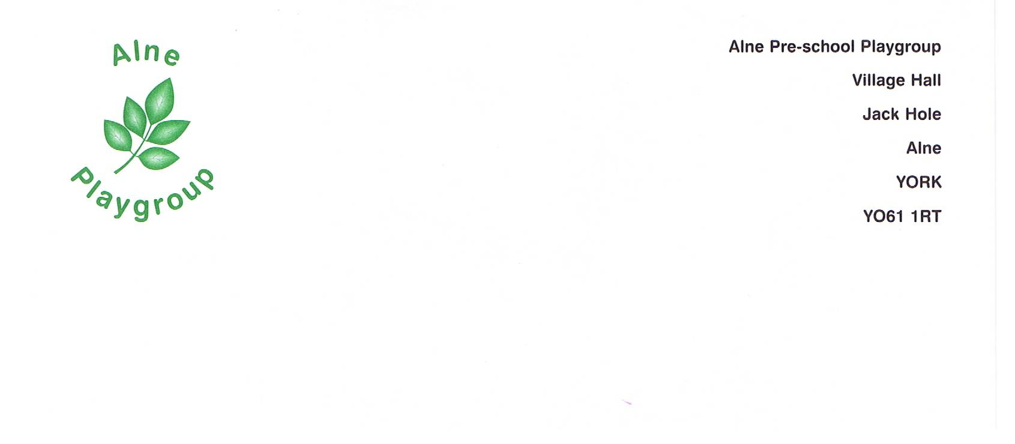

Alne Pre-school Playgroup Behaviour management Policy

EYFS LINKS A Unique Child 1.3 Keeping Safe. 1.4 Health and Well-being
Positive Relationships 2.1 Respecting each other 2.3 Positive interactions

Statement of Intent

At Alne Pre-school Playgroup we believe that children and adults flourish best in an ordered environment in which everyone knows what is expected of them and children are free to develop their play and learning without fear of being hurt or hindered by anyone else. We aim to work towards a situation in which children can develop self-discipline and self-esteem in an atmosphere of mutual respect and encouragement.

Aim: In order to achieve this:

- Rules governing the conduct of the group and the behaviour of the children will be discussed and agreed within the Pre-school and explained to all newcomers, both children and adults.

- All adults in the Pre-school will ensure that the rules are applied consistently, so that children have the security of knowing what to expect and can build up useful habits of behaviour.

- All adults will try to provide a positive model for the children with regard to friendliness, care and courtesy.

- Adults in the Pre-school will praise and endorse desirable behaviour such as kindness and willingness to share.

- We will take positive steps to avoid a situation in which children receive adult attention only in return for undesirable behaviour.

When children behave in unacceptable ways:

- Physical punishment, such as smacking or shaking, will be neither used nor threatened.

- Children will never be sent out of the room by themselves.

- Techniques intended to single out and humiliate individual children such as the ‘naughty chair’ will not be used.

- Children who misbehave will be given one-to-one support in seeing what was wrong and working towards a better pattern of behaviour. Where appropriate this might be achieved by a period of ‘time out’ with a member of staff.

- In cases of serious misbehaviour, such as racial or other abuse, the unacceptability of the behaviour and attitudes will be made clear immediately, but by means of explanations rather than personal blame.

- In any case of misbehaviour, it will always be made clear to the child or children in question that it is the behaviour and not the child that is unwelcome.

- Adults will not shout or raise their voices in a threatening way.

- Adults in the Pre-school will make themselves aware of, and respect a range of cultural expectations regarding interactions between children.

- Any behaviour problems will be handled in a developmentally appropriate fashion, respecting individual children’s level of understanding and maturity.

- Recurring problems will be tackled by the whole Pre-school, in partnership with the child’s parents/carer’s, using objective observation records to establish an understanding of the cause.

- Adults will be aware that some kinds of behaviour may arise from a child’s special needs.

- The group has a named person (Lisa Frost) who has the responsibility for behaviour management issues, who has specific training and access to expert advice if ordinary methods are not effective with a particular child.

This policy was adopted at the Annual General Meeting. Date
Signed…………………………………………. Review date

